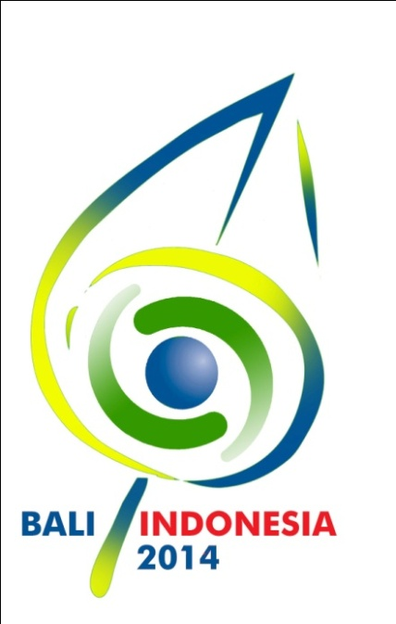
PRELIMINARY TENTATIVE PROGRAMME
SIXTH GLOBAL FORUM OF THE UNITED NATIONS ALLIANCE OF CIVILIZATIONS
BALI – INDONESIA, 29-30 AUGUST 2014
www.unaoc6.or.id

THURSDAY, 28 AUGUST 2014

TIME | EVENT | VENUE
08.00-21.00 | Arrival of all delegations and participants, registration to the Forum | TBC
09.00 – 18.00 | Youth Event  “The role of youth in promoting “Unity in Diversity”  through education, media and migration”  09.00 - 12.00 Discussion session (at BNDCC)  12.00 – 13.00 Lunch  13.30 – 16.00 Cultural activity (field visit)  16.30 – 18.00 Discussion session and wrap up (at BNDCC) | BNDCC 2 (tbc)
16.00 – 18.00 | Focal Points Meeting (by invitation only event for National Focal Points of the members of the UNAOC GoF) | BNDCC 2 (tbc)
17.00-18.00 | Inauguration of the Unity in Diversity “Trail of Civilizations” exhibition | tbc
18.30-  21.30 | Intercultural Innovation Award Ceremony (UNAOC-BMW Group) | BNDCC 2 (tbc)

THURSDAY, 29 AUGUST 2014

TIME | EVENT |  |  | VENUE
08.00 – 09.00 | Arrival of participants |  |  | BNDCC 1  Nusa Dua Hall 5
09.00 – 10.30 | Opening Session:  - H.E. R. M. Marty M. Natalegawa  Minister for Foreign Affairs of the Republic of Indonesia  - H.E. Nassir Abdulaziz Al-Nasser  United Nations High Representative for the Alliance of Civilizations  - H.E. John W. Ashe  President of the 68th United Nations General Assembly  - H.E. Ban Ki-moon  United Nations Secretary-General  - Representative of Spain (as co-sponsor), tbc  - Representative of Turkey (as co-sponsor), tbc  - H.E. Susilo Bambang Yudhoyono  President of the Republic of Indonesia |  |  | BNDCC 1 Nusa Dua Hal 5
10.30 – 11.00 | 1. Press conference  2. Coffee break |  |  | BNDCC 1 (tbc)  Foyer BND Hall
11.00 – 12.45 | Plenary Session 1:  “Unity in Diversity: Celebrating Diversity for Common and Shared Values”  Speakers (tbc) |  |  | BNDCC 1  Nusa Dua Hall 5
12.45-  13.00 | Prayer break |  |  | Prayer and meditation room
13.00 – 13.50 | Lunch (hosted by the Government of the Republic of Indonesia) |  |  | BNDCC 1 (tbc)
14.00-  16.00 | Break-out sessions (four parallel events):  - Session 1  Promoting harmony through inter-religious and cross-cultural education;  - Session 2  Role of women in fostering understanding among cultures;  - Session 3  Fostering understanding through the power of sports, art, music and entertainment;  - Session 4  Youth participation in peace-building | 14.00 – 17.00  UNAOC Group of Friends Ministerial Meeting (for official delegations only - 114 states and 25 international organizations) | 14.00 - 18.00 Side events (six parallel events, partners to be confirmed): | tbc
16.00 – 18.00 | Break-out sessions (four parallel events):  - Session 5  Media conversation across lines:  Building a culture of tolerance in Journalism  - Session 6  Harnessing the positive power of social media.  - Session 7  Social inclusion and migration: developments for post 2015-agenda;  - Session 8  Perception of migration: how to change the narratives about migrants? |  |  | tbc
19.00 – 21.00 | Global Forum Dinner & Cultural Evening (hosted by the Minister for Foreign Affairs of the Republic of Indonesia) |  |  | BNDCC 1 (tbc)

THURSDAY, 30 AUGUST 2014

TIME | EVENT | VENUE
08.00 – 09.00 | Arrival of participants | BNDCC 1  Nusa Dua Hall 5
09.00 – 10.00 | Plenary Session 2:  “Knowing One Another – Urgent Need to Foster Dialogue and Understanding Between Eastern and Western Civilizations”  Speakers: (tbc) | BNDCC 1  Nusa Dua Hall 5
10.00 – 10.15 | Coffee break | tbc
10.15 – 12.15 | Break-out sessions (three parallel events):  - Session 1  The role of culture in the formulation of new sustainable development goals;  - Session 2  The use of interreligious and intercultural approaches to advance the broader interests of mediation in conflict-affected settings;  - Session 3  BBC Debate on media coverage of migration: defining what is and what is not a migrant story | BNDCC 1 (tbc)
12.15 – 13.15 | Closing Session  - Brief report on various sessions, including the Bali Declaration and the youth event  - Closing remarks on the Bali Forum outcomes | BNDCC 1  Nusa Dua Hall 5
13.15 – 14.30 | Lunch (hosted by the Government of the Republic of Indonesia) | BNDCC 1

Note: Throughout the Sixth Global Forum of the UNAOC, side events and bilateral meeting will be convened in parallel with main sessions.
Venue: Side events: Mengwi 2, 3, 5, 6, 7, 8, BNDCC 2; Bilateral meetings: Uluwatu 3, 4, 7a, 7b, BNDCC 1

