
INTERVIEW: ASIA-EUROPE INTERFAITH DIALOGUE IN SEOUL

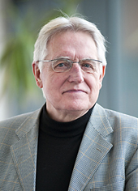
Aarhus University and has participated in the event since its launch in 2005. → (Continued on page 3)
The 5th ASEM (Asia-Europe Meeting) Interfaith Dialogue was held on September 23-25 2009, in Seoul on the theme ‘Bridging Divides through Interfaith Dialogue.’ The dialogue served as a forum to overcome current challenges and to enhance understanding and respect among ASEM partners (including 27 European Union states and 16 Asian countries).
Professor Viggo Mortensen is the Director of the Center for Multireligious Studies at Denmark’s

Dear Foundations Network members,
One of the main features and assets of the Alliance of Civilizations is to bring together governments and civil society around the table in order to come up with adequate responses to improve intercultural dialogue and cooperation. Building strategic partnerships is indeed at the very heart of the mission and "business model" of the Alliance. The complexity, diversity and magnitude of problems to solve require that each partner gives the better of itself, being knowledge, influence, legitimacy, funding capacity, or innovative mind. The Marketplace of Ideas launched in Istanbul aims at embarking all partners - governments, media, foundations,
youth, academics, business, etc.- in supporting the most innovative, creative and successful

have a significant positive impact, that doesn't remain local, but benefits other communities and countries around the world is indeed a tremendous challenge and exciting task.
Based on the success of the Istanbul Forum, the Alliance is working to develop on a larger scale the Marketplace of Ideas and to increase its support to winners by mobilizing a wide range of partners. In this respect, the role of foundations is vital: as a "laboratory", foundations are uniquely placed to encourage innovation; they can also provide the resources, the "venture capital," indispensable to get things off the ground. We very much welcome your input and active participation in this exciting venture as well as the other projects initiated by the Alliance or developed in partnership with a wide range of organizations.
- Alliance of Civilizations Secretariat
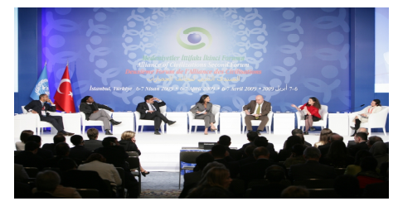

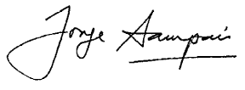

Jorge Sampaio
UN High Representative for the Alliance of Civilizations

AOC STUDY:
CSR PROGRAMS ON INTERCULTURAL DIALOGUE
The Alliance of Civilizations Secretariat is currently conducting a study of corporate sector efforts in the field of intercultural dialogue and understanding. The study will include a mapping of notable and ongoing CSR intercultural projects and details of their specific programs. The Alliance will compile a database of corporations and foundations sponsoring such projects and perform outreach to incorporate them into the existing foundations network towards the end of the year. → Click here to view study progress


TECHNOLOGY FOR PEACE AND UNDERSTANDING
In collaboration with the Alliance of Civilizations, CISCO launched Dialogue Café at the AoC Istanbul Forum held last April. The project is based on a bold but simple idea: ordinary people have more in common than not and given the opportunity will explore their common interests even across radical geo-political divides. Using the latest telepresence technology, the network of Dialogue Cafés aims to become a global platform of conversations and many-to-many interactions connecting ordinary people from diverse backgrounds, religions and culture. It relies upon an “Alliance of Cities of Dialogue Cafés”, a “Charter for Dialogue Cafés” and a global community of users. This project is managed by the Dialogue Café Association (DCA) a non-for-profit association that includes the initial partners – CISCO and AoC – and supporters of the project such as the Gulbenkian Foundation or Anna Lindh Foundation. We are now looking forward to welcoming new partners to this project - governments, international organizations, cities, foundations, companies, NGOs. If you want to know more on the project, please click in www.dialoguecafe.org. If you want to join the project, please contact Sara Piteira, the Executive Director of Dialogue Café (Sara.piteira@dialoguecafe.org)
SUPPORTING
INNOVATION
TOGETHER
initiatives taking place at the field level and to help them scale up and replicate. Making sure that these initiatives

Alliance of Civilizations Developments

LAUNCH OF BUSINESS COALITION FOR INTERCULTURAL DIALOGUE AND COOPERATION
Business leaders from countries around the world gathered on 21 September, 2009 to form an alliance to address the challenges of cultural and religious diversity of today’s global world. Working hand in hand with governments, policymakers, think-tanks and foundations, they launched the first Business Coalition for Intercultural Dialogue and Cooperation at a high-profile event in New York.
Organized jointly by the UN Alliance of Civilizations, the UN Global Compact and the Research Centre for the Global Compact at the Levin Institute, the event was hosted at the Levin Institute on September 21, 2009.
In a keynote address, the Turkish Prime Minister, H.E.. Mr. Recep Tayyip Erdoğan, outlined his vision of the business community’s role in promoting understanding and respect among cultures. He was joined by top business leaders Mr.
Mr. Antonio Brufau, Chairman and CEO of Repsol YPF and Mr. Yue Zhang, Chairman and CEO of China’s Broad Air Conditioning. H.E. President Jorge Sampaio, High Representative for the Alliance of Civilizations, Mr. Georg Kell, Executive Director of the UN Global Compact Office, and H.E. Dr. Ewa Björling, Sweden’s Minister of Trade also
shared their thoughts about promoting cultural diversity.

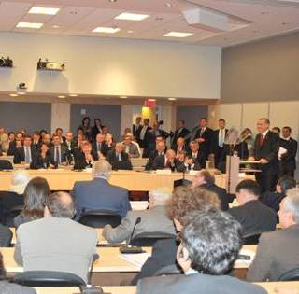

H.E. Mr. Recep Tayyip Erdoğan speaks at the launch of the Business Coalition for Intercultural Dialogue and Cooperation on September 21, 2009.

In addition, the event saw the presentation of a new publication launched in Istanbul aimed at raising the visibility of best practices in the corporate sector toward supporting cross-cultural relations. Jointly developed by the UN Alliance of Civilizations and the UN Global Compact Office, this report is entitled “Doing Business in a Multicultural World: Challenges and Opportunities.” It explores the cross-cultural challenges companies are facing, highlights good practices and lessons learned and illustrates why and how business can play a vital role in fostering intercultural understanding.
Click here to download the Business Coalition concept note.

YOUTH SOLIDARITY FUND
In early 2008, the Alliance of Civilizations established the Youth Solidarity Fund to support youth-led projects addressing areas of primary concern to the AoC. During the pilot phase, over 110 proposals submitted from youth organizations in a total of 55 countries were received. Six outstanding projects were selected and received grants of up to USD$20,000, for a total of USD$100,000. The projects were implemented from September 2008 to April 2009 and a report on results was offered during the Istanbul Forum (click here for more info).
Last month, the second phase of the Youth Solidarity Fund was launched and over 520 applications were received from every corner of the world and especially Africa. The selection process will take place in October and results will be publicly announced in November. The winning projects will receive grants of up to USD$30,000 each, for a total of at least USD$300,000. The Council of Europe will offer training to the coordinators of the winning projects.
For more information, please contact Isabelle Legare at isabellel@unops.org.
COLLABORATIVE FILM PROJECT
The Alliance of Civilizations is joining forces with ART for the World in the production of «Then and Now: Beyond Borders and Differences», a collaborative film project addressing shared beliefs on peaceful coexistence within the world's major religions. ART for The World is an NGO based in Geneva and Milan and is associated with the UN Department of Public Information. « Then and Now : Beyond Borders and Differences » will involve independent well-known artists and filmmakers from five continents to promote tolerance and encourage inclusiveness by creating art works and short films highlighting long-standing historical, spiritual and cultural links across cultures. In 2008, on the occasion of the 60th Anniversary of the UDHR, ART for the World, invited by OHCHR, produced "Stories of Human Rights" a feature film compiling a series of 22 short films directed by prominent filmmakers. The film has been screened at international film festivals and events around the world. For more information, please see: stories on human rights on YouTube, or art-for-the-world.blogspot.com.
Foundations interested in learning more about this project or in supporting it should contact: Adelina von Fürstenberg, Director, ART for The World, 15, Route de Florissant, 1206 Genève - Suisse, Tel. +41 227891557; cell: adelina@artfortheworld.net; www.artfortheworld.net.

→ (Continued from page 1)
INTERVIEW: ASIA-EUROPE MEETING
What is the Asia-Europe Meeting (ASEM) about?
The Asia Europe Meeting is a government sponsored forum for dialogue between Europe and Asia. As a multilateral channel for communication and dialogue between Asia and Europe it engages in intellectual and cultural exchange. In addition for five years now an interfaith dialogue has been facilitated. A country from Asia and one from Europe are co-hosts of the event and several other Asian and European countries act as cosponsors. You end up with a crowd of very interesting people, a mix of diplomats, experts, scholars and religious leaders.

What key messages and outcomes have come out from the event?
Like in many other cases it is true of this endeavour: the process is more important than the product. After each of the talks a statement is produced that declare the good intentions of the involved states and participants. Everybody agrees that if religion is not a part of the solution it will be a part of the problem. If religions want to play a part in the nation building process and thus function as civil religion, they need to tone down their confessional identity and develop structures that allow for others to have full freedom of religion. Respecting minority views is important but this does not exclude that there can be a lead culture in a given society.
What role can foundations play in the process discussed at this meeting?
Foundations like the Asia-Europe Foundation can play a pivotal role in facilitating the encounter between different groups. Working with multipliers such as people from the media and educators they contribute immensely to a heightened awareness of the issues involved. They can stress that we are one world and we belong to one humanity. The commonalities come with the fact that we are all humans; humans endowed with dignity and certain inalienable rights. To overcome the threat of terror and the deadlock in which the war against terror has placed us, we need a more effective strategy of cultural engagement. Here the foundations have an important role to fulfil.
→ Click here for more info on the event

CURRENT PARTNER PROJECTS

Project in Focus: Our Shared Europe (British Council)

EFC mapping of Members working on Religious Issues
The European Foundation Centre has produced a report, which maps EFC members who are currently working on religious issues. The objective of this report is to give an overview of the 22 EFC members working on religious issues both at national and international levels. The report also gives profiles of the funders and was prepared upon request by EFC members and other interested parties. → Click here to access the report

The British Council has set up a program called Our Shared Europe (OSE)* and focused on the rich and diverse contribution Muslim communities have made to Europe’s cultures, identities and societies. We began almost two years ago, with consultation and research in countries across Europe and North Africa, into what Muslims wanted – and did not want – to see aired. A report was published (and is

available on the project website at http://www.oursharedeurope.org/) and OSE is built on that research. It is quite clear in its objective: to promote the understanding that ‘Muslims are an integral part of Europe’s past, present and future’. Interestingly, we have found over the last few months that the most controversial part of this statement is often ‘the past’. It seems that our inherited Eurocentric worldview and our subliminally retro-fitted account of Europe’s own cultural and political development do not allow us easily to admit that Muslims have been an important factor in the European story.
OSE approaches this cultural borderland with the tools of cultural relations, and with the objective of relationship-building, trust-earning and increased mutual knowledge. The project is not a definitive set of actions set out in advance by the British Council: we are clear that OSE is a partnership project, and while in its initial stages at least, the British Council will delineate and lead much of the work, the work-plans and the approaches will be (and already are being) defined with our partners.
Now in its first 12-month trial period, OSE will grow rapidly. It will soon cover all the countries of Europe with significant Muslim populations – which means virtually all European countries. It will follow the migration paths that have brought Muslims from the old empires into Europe, especially since the war, involving their countries of origin in OSE. And it will cross the Atlantic to collaborate with partners in North America. This expansion is happening faster than we originally planned, as partnerships with organizations like the UN Alliance of Civilizations and many others help define our work. * This project was also featured at the 2009 AoC Istanbul Forum. Click here to view the Istanbul Forum Report.

By Martin Rose (Director, Our Shared Europe, The British Council)
PEW STUDY ON GLOBAL MUSLIM POPULATION
The Pew Research Center's Forum on Religion & Public Life has released a new study titled “Mapping the Global Muslim Population: A Report on the Size and Distribution of the World's Muslim Population”. The demographic study looks at the size and geographic distribution of approximately 1.57 billion Muslim around the world and is the largest of its type to date. → Click here to download the report

Partner Updates

OTHER UPCOMING EVENTS (more details available at www.aocerb.org and http://tinyurl.com/ya5mseg)

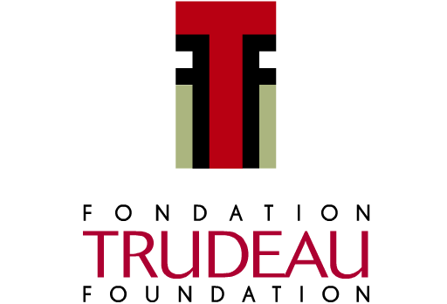
The Trudeau Foundation will be conducting a workshop titled “Citizenship in the City: Exploring the Kind of Problem a City is” in Ottawa from November 18-19, 2009. The workshop will look into the meaning of urban citizenship and explores areas of civic engagement and marginalized communities.
→ Click here for more info

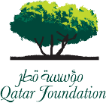
The Qatar Foundation will be hosting the first World Innovation Summit for Education (WISE) in Doha from November 16-18, 2009. The summit will draw international experts on education worldwide to debate and propose new education models for the 21st century.
→ Click here for more info

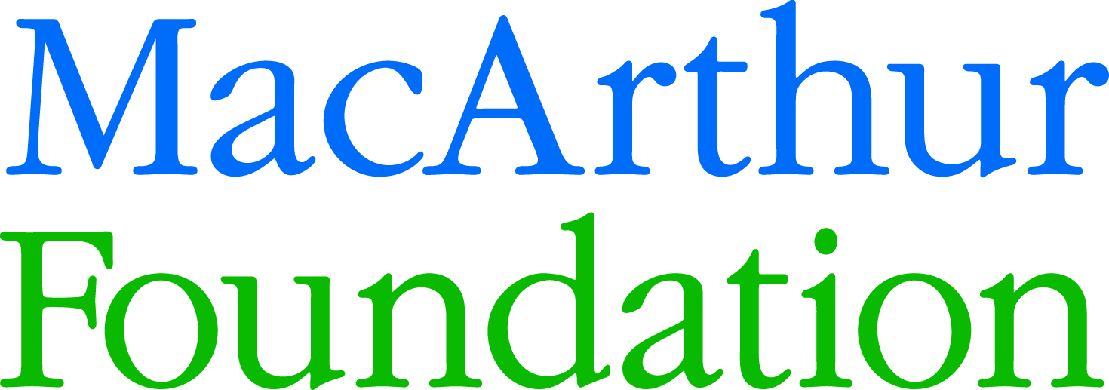

Early in May 2009, the MacArthur Foundation committed $68 million to a new Asia Security Initiative, bringing together 27 institutions globally to tackle Asia’s security challenges and foster an environment of peace. Part of this initiative will be the introduction of fellowships in 2010 to mid-career leaders in civil, private and governmental sectors to focus on policy research in this area.
→ Click here for more info

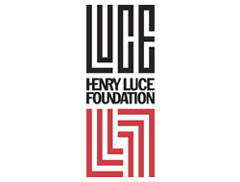
The Henry Luce Foundation recently finalized its list of sixteen 2009-2010 Luce Scholars, selected from 111 candidates from 55 colleges and universities. The Luce Scholars represent prospective leaders in American society who are placed in countries or regions in East and Southeast Asia as part of a cultural exchange. The program is administered in Asia by the Asia Foundation.
→ Click here for more info

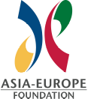
The Asia-Europe Foundation organized its 6th Journalists’ Colloquium on the theme ‘Keeping the Faith: Reporting on Religion’. Held in Seoul, ahead of the 5th ASEM Interfaith Dialogue, the two-day colloquium brought a select group of Asian and European faith leaders and journalists to discuss the challenges and opportunities of their collaboration in promoting interfaith dialogue.
→ Click here for more info


The 2nd World Young Leaders Forum will be hosted by the BMW Foundation Herbert Quandt in Mumbai from November 26-29, 2009. The Forum’s theme this year is “Social Cohesion” and will join young leaders from 45 countries to delve into social cohesion as defined in different cultures and countries.
→ Click here for more info

∙ The University of Barcelona in Spain will be hosting the “Conference on Changing Cultures: Cultures of Change,” exploring topological, quantitative and qualitative methods of viewing cultural change. The conference will be held on the university’s campus on December 10-12,2009.
∙ RWTH Aachen University in cooperation with Imperial College London, ETH Zürich and TU Delft will be hosting the conference “Going Diverse: Innovative Answers to Future Challenges,” highlighting aspects of gender and diversity in science, technology and business in the wake of globalization. The conference will occur October 29-30, 2009.
∙ The second edition of the international Forum for The Young Mediterranean Leaders (YML) will be held on November 5-7, around the theme “Redefining the Mediterranean space: the utopia of Euro-Maghreb.” The Young Mediterranean Leaders (YML) form an exclusive network of young decision-makers from all geographical and professional backgrounds, committed to bridging the two shores of the Mediterranean through concrete projects.
∙ Tanenbaum will be opening nominations for Peacemakers in Action and Women's Peace Initiative awards for leaders in the field of religion and conflict resolution. The nominations will be open from October 1 - November 30.
∙ Sidi Mohamed Ben Abdellah University will hold a conference entitled “Comparative Religions: Challenges of the Present and Prospects for the Future” on October 21-22, 2009 in Morocco. The conference will look into the necessity of religious dialogue, how religion may be more scientifically studied in academia circles and the absence of comparative religion disciplines in much of the Arab and Muslim world.

